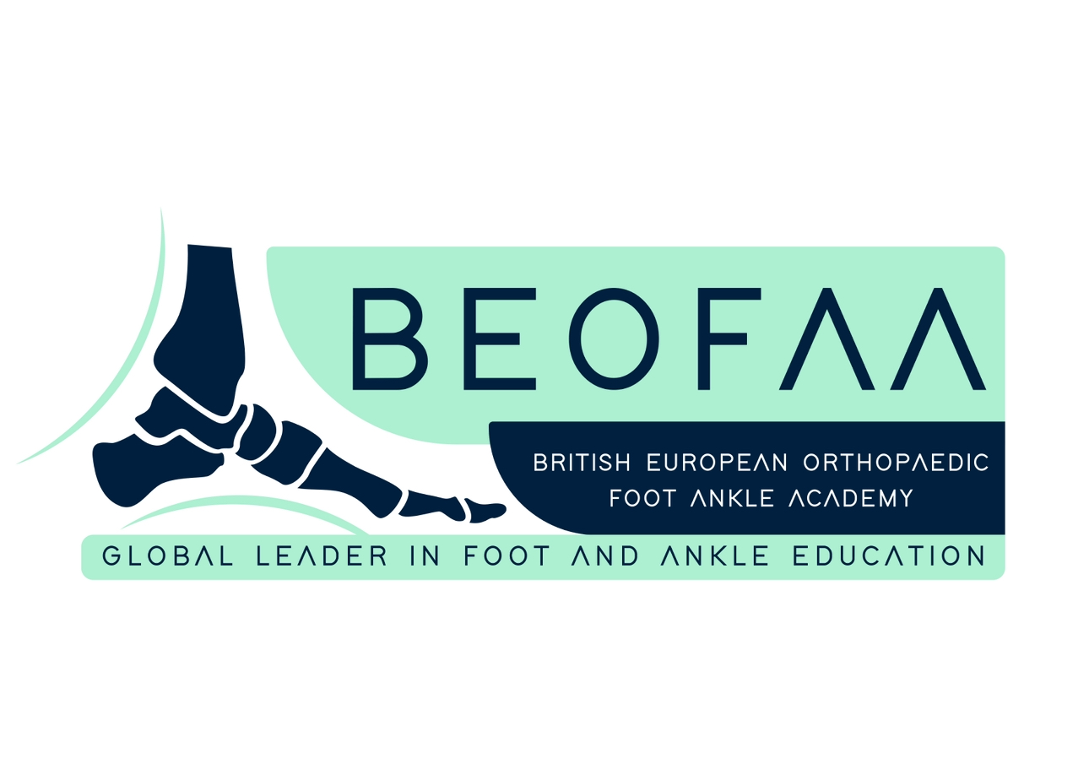
2nd BEOFAA FOOT & ANKLE SYMPOSIUM
Advanced Techniques • Complex Decision-Making • Case-Based Learning
23–24 OCTOBER 2026 | ISTANBUL, TÜRKİYE
Radisson Blu Hotel, Istanbul Sisli
19 Mayis Street No 2, Sisli, Istanbul, Türkiye
A high-level, case-driven meeting for current and alumni BEOFAA fellows, bringing together expert faculty for practical surgical teaching, advanced reconstruction strategies and interactive peer learning.
INTERNATIONAL FACULTY
Prof Maneesh Bhatia  Course Director • Leicester, UK | Manuel Monteagudo  Course Director • Madrid, Spain
Mark Davies  Sheffield, UK | Nick Cullen  Stanmore, UK
Norman Espinosa  Zurich, Switzerland | Tim Clough  Wrightington, UK
Lucky Jeyaseelan  London, UK | Yasser Aljabi  Dublin, Ireland
Bedri Karaismailoglu
Istanbul, Türkiye

CPD / event information

DAY 1 • FRIDAY, 23 OCTOBER 2026
THEME: COMPLEX DEFORMITY CORRECTION
TIME | SESSION | FACULTY
08:00–08:50 | Registration, Coffee & Networking
08:50–09:00 | Welcome & Opening Remarks | Course Directors
09:00–09:20 | Assessment & Planning of Complex Foot and Ankle Deformity | Mark Davies
09:20–09:40 | Hallux Valgus Correction: The Open Approach | Tim Clough
09:40–10:00 | Hallux Valgus Correction: The MIS Approach | Bedri Karaismailoglu
10:00–10:20 | Pes Planovalgus Correction: Principles, Planning & Technique | Maneesh Bhatia
10:20–10:40 | Tarsometatarsal, Talonavicular, Subtalar & Calcaneocuboid Fusion: Indications & Surgical Strategy | Manuel Monteagudo
10:40–11:00 | Cavovarus Correction: From Assessment to Reconstruction | Nick Cullen
11:00–11:20 | Panel Discussion & Q&A | Faculty
11:20–11:45 | Tea / Coffee Break & Networking
11:45–13:30 | Hands-on Deformity Correction Workshop: Hallux Valgus, Pes Planovalgus & Cavovarus | All Fellows & Faculty
13:30–14:30 | Lunch & Networking
14:30–14:50 | 3D Technologies & Patient-Specific Guides in Foot and Ankle Surgery: From Scan to Scalpel | Bedri Karaismailoglu
14:50–15:10 | Supramalleolar Osteotomy: Planning, Correction & Surgical Technique | Norman Espinosa
15:10–15:30 | Tibiotalocalcaneal & Tibiocalcaneal Fusion: MIS Techniques & Surgical Strategy | Lucky Jeyaseelan
15:30–15:50 | Tibiotalocalcaneal & Tibiocalcaneal Fusion: Open Techniques & Surgical Strategy | Mark Davies
15:50–16:10 | Panel Discussion & Q&A | Faculty
16:10–16:40 | Tea / Coffee Break
16:40–18:00 | Meet the Authors • Surgical Techniques of the Foot & Ankle  A celebration of the new book with author insights, selected techniques and interactive discussion | Book Authors

DAY 2 • SATURDAY, 24 OCTOBER 2026
TRAUMA • SPORTS • CARTILAGE • ANKLE REPLACEMENT
TIME | SESSION | FACULTY
09:00–09:20 | Calcaneal Fractures: Reduction Strategy & Surgical Technique | Lucky Jeyaseelan
09:20–09:40 | Syndesmotic Injuries: Decision-Making, Fixation & Practical Tips | Maneesh Bhatia
09:40–10:00 | Posteromedial Approach for Ankle Fractures: Why, When & How? | Lucky Jeyaseelan
10:00–10:30 | Panel Discussion & Q&A | Faculty
10:30–11:00 | Tea / Coffee Break
11:00–12:30 | Case-Based Masterclass: Complex Foot & Ankle Decision-Making | All Fellows & Faculty
12:30–13:30 | Lunch & Networking
13:30–13:50 | Sports Injuries in the Athlete: Surgical Decision-Making & Return to Sport | Manuel Monteagudo
13:50–14:10 | Ankle Cartilage Injuries: Contemporary Surgical Strategies | Nick Cullen
14:10–14:30 | Total Ankle Replacement: Patient Selection, Planning & Surgical Pearls | Yasser Aljabi
14:30–14:50 | Total Ankle Replacement: Mastering Alignment, Balancing & Implant Positioning | Norman Espinosa
14:50–15:10 | Panel Discussion & Q&A | Faculty
15:10–15:30 | Symposium Highlights, Certificates & Closing Remarks | Course Directors
BEOFAA • GLOBAL LEADER IN FOOT AND ANKLE EDUCATION

